This article comes from [Jennifer Cooper](https://www.linkedin.com/in/jennifermariecoopermba/), a new student in [Business Science University](https://university.business-science.io/?affcode=173166_fpyudtfo). Jennifer is 35% complete with the 101 course – and shows off her progress in this ***PDF Scraping tutorial***. Jennifer has an interest in understanding the *plight of wildlife* across the world, and uses her new data science skills to perform a useful analysis – ***scraping PDF tables of a Report on Endangered Species with the tabulizer R package and visualizing alarming trends with ggplot2***.

**Scraping PDFs and Analyzing Endangered Species**

by Jennifer Cooper, Marketing Data Scientist at Skopos Financial

Hey, everybody! Hope everyone has had a great weekend !!

I’ve been “heads down” this weekend working on a special R project. This week I gave myself a challenge to start using R at work and also come up with a project on the side that I could use to help review what I’ve learned so far in [Business Science University’s DS4B 101-R course](https://university.business-science.io/p/ds4b-101-r-business-analysis-r/?coupon_code=ds4b15&affcode=173166_fpyudtfo).

In addition to being passionate about data science, I also love animals and am concerned about the plight of wildlife across the world, particularly with climate change. I decided to take a look at data on critically endangered species.

The only information on Endangered Species I could find was in a **PDF format**, so I spent a lot of time trying to figure out the nuances of tabulizer for scraping PDF. I finally got it done tonight!

Through this process, I discovered I still need a lot more practice, so I’m going to continue seeing what I can do to apply it at work (figure out how to connect to our SQL database this week), carve out more time to practice, and I may write up an article on working with tabulizer and PDFs.

Interested in learning R? [Join me in the 101 course](https://university.business-science.io/p/ds4b-101-r-business-analysis-r/?coupon_code=ds4b15&affcode=173166_fpyudtfo).

**My Workflow**

Here’s a diagram of the workflow I used:

1. Start with PDF
2. Use tabulizer to extract tables
3. Clean up data into “tidy” format using tidyverse (mainly dplyr)
4. Visualize trends with ggplot2

[[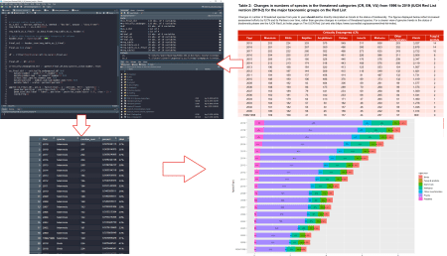](https://www.business-science.io/code-tools/2019/09/23/tabulizer-pdf-scraping.html#workflow)](https://www.business-science.io/code-tools/2019/09/23/tabulizer-pdf-scraping.html#workflow)

[My Code Workflow for PDF Scraping with tabulizer](https://www.business-science.io/code-tools/2019/09/23/tabulizer-pdf-scraping.html#workflow)

**Get the PDF**

I analyzed the [Critically Endangered Species PDF Report](https://github.com/Coopmeister/data_science_r_projects/blob/master/endangered_species.pdf).

**PDF Scrape and Exploratory Analysis**

**Step 1 – Load Libraries**

Load the following libraries to follow along.

library(rJava) # Needed for tabulizer

library(tabulizer) # Handy tool for PDF Scraping

library(tidyverse) # Core data manipulation and visualization libraries

Note that tabulizer depends on rJava, which may require some setup. Here are a few pointers:

* **Mac Users:** If you have issues connecting Java to R, you can try running sudo R CMD javareconf in the Terminal ([per this post](https://github.com/rstudio/rstudio/issues/2254))
* **Windows Users:** [This blog article](https://cimentadaj.github.io/blog/2018-05-25-installing-rjava-on-windows-10/installing-rjava-on-windows-10/) provides a step-by-step process for installing rJava on Windows machines.

**Step 2 – Extracting the Tabular Data from PDF**

The tabulizer package provides a suite of tools for extracting data from PDFs. The vignette, [“Introduction to tabulizer”](https://cran.r-project.org/web/packages/tabulizer/vignettes/tabulizer.html) has a great overview of tabulizer’s features.

We’ll use the extract_tables() function to pull out each of the tables from the Endangered Species Report. This returns a list of data.frames.

# PDF Scrape Tables

endangered_species_scrape <- extract_tables(

file = "2019-09-23-tabulizer/endangered_species.pdf",

method = "decide",

output = "data.frame")

The table I’m interested in is the first one – the Critically Endangered Species. I’ll extract it using the pluck() function and convert it to a tibble() (the tidy data frame format). I see that I’m going to need to do a bit of cleanup.

# Pluck the first table in the list

endangered_species_raw_tbl <- endangered_species_scrape %>%

pluck(1) %>%

as_tibble()

# Show first 6 rows

endangered_species_raw_tbl %>% head() %>% knitr::kable()

| **X** | **X.1** | **X.2** | **X.3** | **Critically.Endangered..CR.** | **X.4** | **X.5** | **X.6** | **X.7** | **X.8** |
| --- | --- | --- | --- | --- | --- | --- | --- | --- | --- |
| Year | Mammals | Birds | Reptiles | Amphibians Fishes Insects | Molluscs | Other invertebrates | NA | Plants | Fungi & protists |
| 2019 | 203 | 224 | 303 | 575 549 311 | 658 | 263 | NA | 3,027 | 14 |
| 2018 | 201 | 224 | 287 | 550 486 300 | 633 | 252 | NA | 2,879 | 14 |
| 2017 | 202 | 222 | 266 | 552 468 273 | 625 | 243 | NA | 2,722 | 10 |
| 2016 | 204 | 225 | 237 | 546 461 226 | 586 | 211 | NA | 2,506 | 8 |
| 2015 | 209 | 218 | 180 | 528 446 176 | 576 | 209 | NA | 2,347 | 5 |

**Step 3 – Clean Up Column Names**

Next, I want to start by cleaning up the names in my data – which are actually in the first row. I’ll use a trick using slice() to grab the first row, and the new pivot_longer() function to transpose and extract the column names that are in row 1. I can then set_names() and remove row 1.

# Get column names from Row 1

col_names <- endangered_species_raw_tbl %>%

slice(1) %>%

pivot_longer(cols = everything()) %>%

mutate(value = ifelse([is.na](http://is.na)(value), "Missing", value)) %>%

pull(value)

# Overwrite names and remove Row 1

endangered_species_renamed_tbl <- endangered_species_raw_tbl %>%

set_names(col_names) %>%

slice(-1)

# Show first 6 rows

endangered_species_renamed_tbl %>% head() %>% knitr::kable()

| **Year** | **Mammals** | **Birds** | **Reptiles** | **Amphibians Fishes Insects** | **Molluscs** | **Other invertebrates** | **Missing** | **Plants** | **Fungi & protists** |
| --- | --- | --- | --- | --- | --- | --- | --- | --- | --- |
| 2019 | 203 | 224 | 303 | 575 549 311 | 658 | 263 | NA | 3,027 | 14 |
| 2018 | 201 | 224 | 287 | 550 486 300 | 633 | 252 | NA | 2,879 | 14 |
| 2017 | 202 | 222 | 266 | 552 468 273 | 625 | 243 | NA | 2,722 | 10 |
| 2016 | 204 | 225 | 237 | 546 461 226 | 586 | 211 | NA | 2,506 | 8 |
| 2015 | 209 | 218 | 180 | 528 446 176 | 576 | 209 | NA | 2,347 | 5 |
| 2014 | 213 | 213 | 174 | 518 443 168 | 576 | 205 | NA | 2,119 | 2 |

**Step 4 – Tidy the Data**

There are a few issues with the data:

1. **Remove columns with NAs:** Column labelled “Missing” is all NA’s – We can just drop this column
2. **Fix columns that were combined**: Three of the columns are combined – Amphibians, Fishes, and Insects – We can separate() these into 3 columns
3. **Convert to (Tidy) Long Format for visualization**: The data is in “wide” format, which isn’t tidy – We can use pivot_longer() to convert to “long” format with one observation for each row
4. **Fix numeric data stored as character**: The numeric data is stored as character and several of the numbers have commas – We’ll remove commas and convert to numeric
5. **Convert Character Year & species to Factor**: The year and species columns are character – We can convert to factor for easier adjusting of the order in the ggplot2 visualizations
6. **Percents by year**: The visualizations will have a percent (proportion) included so we can see which species have the most endangered – We can add proportions by each year

endangered_species_final_tbl <- endangered_species_renamed_tbl %>%

# 1. Remove columns with NAs

select_if(~ !all([is.na](http://is.na)(.))) %>%

# 2. Fix columns that were combined

separate(col = `Amphibians Fishes Insects`,

into = c("Amphibians", "Fishes", "Insects"),

sep = " ") %>%

# 3. Convert to (Tidy) Long Format for visualization

pivot_longer(cols = -Year, names_to = "species", values_to = "number") %>%

# 4. Fix numeric data stored as character

mutate(number = str_remove_all(number, ",")) %>%

mutate(number = as.numeric(number)) %>%

# 5. Convert Character Year & species to Factor

mutate(Year = as_factor(Year)) %>%

mutate(species = as.factor(species)) %>%

# 6. Percents by year

group_by(Year) %>%

mutate(percent = number / sum(number)) %>%

mutate(label = scales::percent(percent)) %>%

ungroup()

# Show first 6 rows

endangered_species_final_tbl %>% head() %>% knitr::kable()

| **Year** | **species** | **number** | **percent** | **label** |
| --- | --- | --- | --- | --- |
| 2019 | Mammals | 203 | 0.0331320 | 3.3% |
| 2019 | Birds | 224 | 0.0365595 | 3.7% |
| 2019 | Reptiles | 303 | 0.0494532 | 4.9% |
| 2019 | Amphibians | 575 | 0.0938469 | 9.4% |
| 2019 | Fishes | 549 | 0.0896034 | 9.0% |
| 2019 | Insects | 311 | 0.0507589 | 5.1% |

**Step 5 – Visualize the Data**

**Summary Visualization**

I made a summary visualization using stacked bar chart to show the alarming trends of critically endangered species over time.

endangered_species_final_tbl %>%

mutate(Year = fct_rev(Year)) %>%

ggplot(aes(x = Year, y = number, fill = species)) +

# Geoms

geom_bar(position = position_stack(), stat = "identity", width = .7) +

geom_text(aes(label = label), position = position_stack(vjust= 0.5), size = 2) +

coord_flip() +

# Theme

labs(

title = "Critically Endangered Species",

y = "Number of Species Added to Critically Endangered List", x = "Year"

) +

theme_minimal()

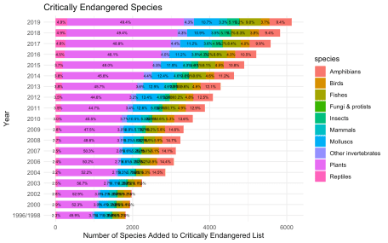

**Trends Over Time by Species**

I then faceted the species and visualized the trend over time using a smoother (geom_smooth). Again, we see that each of the species exhibit increasing trends.

endangered_species_final_tbl %>%

mutate(Year = fct_rev(Year)) %>%

# Geom

ggplot(aes(Year, number, color = species, group = species)) +

geom_point() +

geom_smooth(method = "loess") +

facet_wrap(~ species, scales = "free_y", ncol = 3) +

# Theme

expand_limits(y = 0) +

theme_minimal() +

theme(legend.position = "none",

axis.text.x = element_text(angle = 45, hjust = 1)) +

labs(

title = "Critically Endangered Species",

subtitle = "Trends Not Improving",

x = "", y = "Changes in Number of Species in Threatened Category"

)

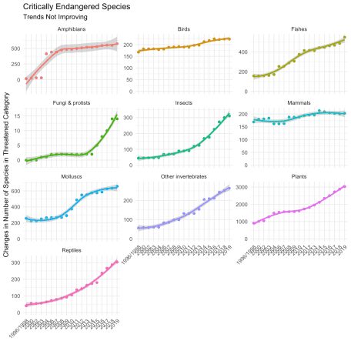

**Parting Thoughts**

**It was really exciting to see my hard work pay off.** It took a bit to get going, but I found that tabulizer made PDF extraction manageable. The most challenging part was getting the data into a format that can be easily visualized (the tidyverse really helped as shown in Step 4!). I was particularly excited to see results of my analysis, and I want to share with others the effects of

**If you’d like to join me**, I’m currently learning Data Science for Business in [Business Science’s 101 course (Data Science Foundations)](https://university.business-science.io/p/ds4b-101-r-business-analysis-r/?coupon_code=ds4b15&affcode=173166_fpyudtfo), and I’ve signed up for 201 Advanced Machine Learning and 102 Shiny Web Applications.